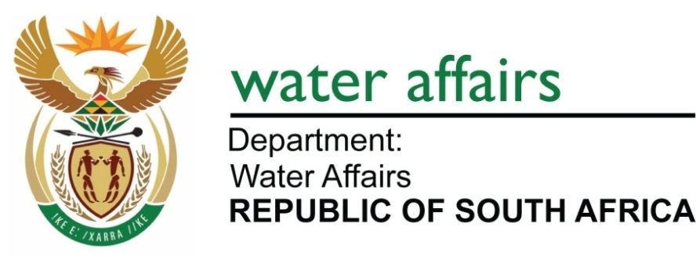

**Directorate: National Water Resource Planning**

**STRATEGY STEERING COMMITTEE OF THE VAAL RIVER SYSTEM**

**PROGRESS REPORT - OCTOBER 2011**

1. **INTRODUCTION**

The fifth meeting of the strategy steering committee (SSC) was held on 19 October 2011 to discuss the progress with the implementation of the Reconciliation Strategy for the Vaal River System (VRS).

The meeting was attended by 46 stakeholders representing key national and provincial government departments, municipalities, water service providers, industry and Non Governmental Organisations as well as agriculture. (The membership list of the SSC is attached to this report as Appendix A.)

Comprehensive progress feedback on each strategy action was given by representatives of the responsible organisations. The conclusions from these presentations still indicate that sufficient water can be made available until the year 2034, but **only** if all the actions are implemented and the set targets are achieved.

The strategic actions needed are:

* Eradicate unlawful irrigation water use by the year 2013;
* Continue with the implementation of Water Conservation and Water Demand Management (WC/WDM) to achieve further targeted savings of 180 million m3/annum by the year 2015;
* Implement Phase 2 of Lesotho Highlands Water Project (LHWP) to deliver water by the year 2020; and
* Integrated Water Quality of the Vaal River System must be adequately addressed. The studies to address facets of the Integrated Water Quality Management are progressing, but progress in dealing with nutrient enrichment is not supported by monitoring evidence. In addition, funding and commitment are urgently required to solve Acid Mine Drainage over the long term.

A summary of the progress with each strategy action is given below.

1. **Implementation of Strategy**
   1. **Eradication of unlawful irrigation water use in the Vaal River System**

From the experience gained in the Vaal River, it has become clear that regulations to enforce the measurement of water abstraction for irrigation purposes is a prerequisite for efficient and effective action against partially unlawful water users, as this will reduce the responsible authority’s burden of proof. Until such regulations have been published, action against partially unlawful water users would be problematic.

The Department must be able to prove beyond reasonable doubt, in a Court of Law or at the Tribunal that an irrigator is over abstracting or unlawfully using water. The available tools in the NWA have therefore to be strengthened by appropriate and supporting regulations required for limiting, monitoring, measuring and recording of irrigation water use. Draft regulations have been cleared with the Chief State Law Advisor and a submission has been made for publishing the draft Regulations for public comment. The publication for comment is therefore imminent.

The initial project plan was based on the premise that the regulations to enforce measurement of water use would be published during the third quarter of 2011. This did not materialise and the project targets were revised accordingly. In view of the above, the aim is to address 47% of the illegal volume identified in the Vaal River System before the end of 2011. The publication of the regulations for comment is imminent but until these are in place the focus will remain on water users where all the present water use is regarded as possibly unlawful.

Validation of water use has been completed in the Upper and Middle Vaal Water Management Areas (WMA) and has commenced in the Lower Vaal WMA. The verification of water use is underway in the Upper and Middle Vaal WMAs.

A programme for the project with deliverables based on the final Project Execution Plan aims to address 75% of the identified unlawful water use by the end of the first quarter of 2012. The targets for addressing the balance of the illegal use during the 2012/13 financial year will be developed and included in further reports.

Unlawful water use in the VRS is still estimated at 244 million m³/a.

The majority of the SSC is of the opinion that many aspects of this action have fallen into place which gives hope that the DWA will succeed in eradicating unlawful water use. This strategic action was slow to start due to the relevant regulations not yet being in place, but will soon pick up momentum. There are, however, risks involved such as the potential legal quagmire.

* 1. **Reduction in municipal water use by 15% through Water Conservation and Water Demand Management**

The total water demand for the Gauteng municipalities has increased and follows the projected high demand with no Water Conservation and Water Demand Management (WC/WDM) interventions. The high proportion of unaccounted for water use has been highlighted in all local authorities.

The City of Tshwane is the only municipality on track with Project 15%. The other municipalities must increase their drive on the implementation of Project 15%. Regular meetings with municipalities are being held to monitor progress and performance and municipalities have to report regularly to the Gauteng MEC for Local Government and Housing as well as the DWA.

The prioritizing of funding within municipalities remains the main key stumbling block for the implementation of WC/WDM. Most municipalities’ prioritization and reliable budgeting for water related infrastructure spending is weak. This is reflected by the declining budget allocations for future years, whereas in practice infrastructure spending will in all probability have to be increased. This is because most municipalities only plan their infrastructure spending within a one-year time horizon. Even then the quality of planning is poor, resulting in significant under spending of capital budgets. In 2009/10 municipalities under spent their capital budgets by R15 billion.

National Treasury has written to all municipalities stating that Non Revenue Water (NRW) is a significant threat to municipal revenue and impacts negatively on overall financial sustainability and that all possible steps must be taken to reduce NRW.

National Treasury wants municipalities to save money and sees WC/WDM as the perfect tool for municipalities to obtain that goal. This created a synergy between Treasury which is interested in the effective monetary value of water provided, sold and managed and the DWA, which is interested in effective water use and reduced losses.

The SSC is very concerned about this project and feels there are major risks to this project due to municipalities not prioritizing budget for water related infrastructure and to meet their respective WCWDM targets. However, the successes of the few metros and municipalities who are achieving reductions in water use must also be commended, such as the City of Tshwane.

* 1. **Implementation of Phase 2 of the Lesotho Highlands Water Project**

South Africa and Lesotho signed an agreement in Maseru on 11 August 2011 for the implementation of the second phase of the Lesotho Highlands Water Project (LHWP). Phase 2 of the LHWP will consist of the building of the Polihali Dam and a water delivery system to supplement the water in the VRS.

The agreement should be ratified by Parliament during November 2011. The project is still on schedule and the dam should deliver water by 2020.

The SSC is confident that this project is on track but a tight rein must be kept on the time frames, because the VRS needs a new operational dam by 2020.

* 1. **Progress of the Water Quality Management Strategy and the management of Acid Mine Drainage**

Good progress is being made with the implementation of various elements of the Integrated Water Quality Management (IWQM) Strategy; including addressing the Acid Mine Drainage problem in the Witwatersrand.

A Due Diligence Review on available infrastructure and potential solutions was concluded in July 2011 and short-term treatment solutions for each of the three basins has been conceptualised.

An immediate solution approved for the Western Basin (Krugersdorp) will improve the discharge of treated mine water from 12 Ml/day to 32 Ml/day. It will be increased to 60 Ml/day until the environmental critical level (ECL) has been achieved. Surface and groundwater monitoring systems are in place with further improvements planned to support short-term interventions.

The DWA and the TCTA have met with liquidators to understand the situation at the Grootvlei Mine (ex Pamodzi Gold) in the Eastern Basin. Environmental impact assessment processes have commenced as well as engagement with interested and affected parties (I&APs). The ECL have been finalised for all three Basins.

Characteristics of an ideal solution to the AMD problem should include:

* Suitable technology;
* Limited waste products (preferably with an economic value);
* Eliminate underground mine water related salt-loading;
* Appropriate institutional and economic models;
* Financially sustainable (without a subsidy from the fiscus);
* Legally sound;
* Acceptable risk profile;
* Public buy-in;
* Protect the environment;
* Mechanism to facilitate mine closure; and
* A “self-sustainable” solution.

Additional funding of R700 million is required from National Treasury to ensure the implementation of short term measures. A total of R225 million has already been made available for the near future.

In terms of water quality in the Vaal River System, the total dissolved solids (TDS) concentrations generally comply to the resource water quality objectives (RWQOs), with non-compliance observed below Vaalharts up to the confluence with the Lower Orange River. Comparisons of the 95 percentile TDS concentrations for 2005 and 2011 yielded improving trends all over, with the exception again of below Vaalharts up to the confluence. In addition, the 50 percentile phosphate concentrations for the 4 phosphate management reaches were compared for 2005 and 2011, and to the RWQOs.

Although comparisons of the phosphate concentrations for 2005 and 2011 yielded improving trends all over, phosphate concentrations observed in the Middle Vaal River generally do not comply with the determined RWQOs, potentially causing hypertrophic conditions conducive to the growth of nuisance algae.

The SSC is extremely worried about the lack of funding and the timeframes of this project. Government and the DWA must take major decisions in a very short period of time or else this project will fail.

* 1. **Vaal River System Classification Study**

The classification of significant water resources in the three Vaal Water Management Areas (WMAs) is on target. The goal of the study is the implementation of the Water Resource Classification System (WRCS) in the three Vaal WMAs according to the 7-step process proposed by the WRCS.

The first three steps of the 7-step process have almost been completed:

**Step 1:** The IUAs have been delineated. The identification and selection of the IUAs were based on the following considerations:

* The resolution of the hydrological analysis and available water resource network configurations;
* Location of significant water resource infrastructure;
* The biophysical nodes, Present Ecological State and Recommended Ecological Category for each node were also considered; and
* Socio-economic zones.

**Step 2:** The socio-economic and ecological value and condition of the water resources have been linked.

**Step 3:** The process to quantify ecological water requirements and changes in non-water quality ecosystem goods, services and attributes have begun and the first draft report has been handed in to the DWA.

The SSC is confident that this project will ensure that a balance is sought between the need to protect and sustain water resources on one hand and the need to develop and use them on the other.

* 1. **Reconciliation Scenarios Review**

The system water balance and reconciliation scenarios are constantly being revised as information changes regarding water use and return flows; revised water requirement and return flow scenarios; possible transfers to the Crocodile West River System, mine effluent management scenarios as well as the eradication of unlawful irrigation water use.

Revised water requirement scenarios were received from Eskom, Sasol, Midvaal Water Company, Sedibeng Water as well as from the All Town Reconciliation Strategy Study. This is summarised in **Figure 1** showing the following:

* The dotted lines represent the scenarios applied for the water balances presented at the October 2010 and April 2011 SSC meetings and the solid lines the revised scenarios.
* The three sets of scenarios are:

1. High water requirement scenarios derived from a high population growth scenario accounting for migration patterns driven by socio economic conditions.
2. The “High with Eradication of Unlawful Water Use” scenarios represent the case where 85% of the perceived unlawful irrigation water use is removed.
3. In addition to item 2 above, the third scenario, “High Water Requirement Scenario with Water Conservation and Water Demand Management” incorporate the potential savings that need to be achieved through the implementation of Project 15%.

* All scenarios show lower water requirements which reflect the reductions in the revised projection scenarios received from Eskom (lower projected water use over the period up to the year 2018), Sasol (lower for both the Secunda and Sasolburg plants), Sedibeng Water as well as Mittal Steel.
* It should be noted that although the water requirement scenario received from Eskom indicated a substantial reduction in water need after the year 2020, the assumption was made in **Figure 1** that the water demand remain constant at the 2020 level. This represents a conservative approach and makes provision for the uncertainties relating to the possible long term future need for water from the Crocodile West or Olifants River Systems.
* The purple and blue solid lines indicate distinct reductions in water requirements until the year 2014, which reflect the respective savings to be achieved by the eradication of the unlawful irrigation water use and the implementation of water conservation and water demand management measures.



**Figure 1: Net System Water Requirement Scenarios (dotted lines – April 2010 scenarios, solid lines revised scenarios October 2011)**

The outcome of the target reconciliation scenario is presented in **Figure 2** which shows that a positive water balance can be maintained until the year 2050 if all the strategy actions are implemented.

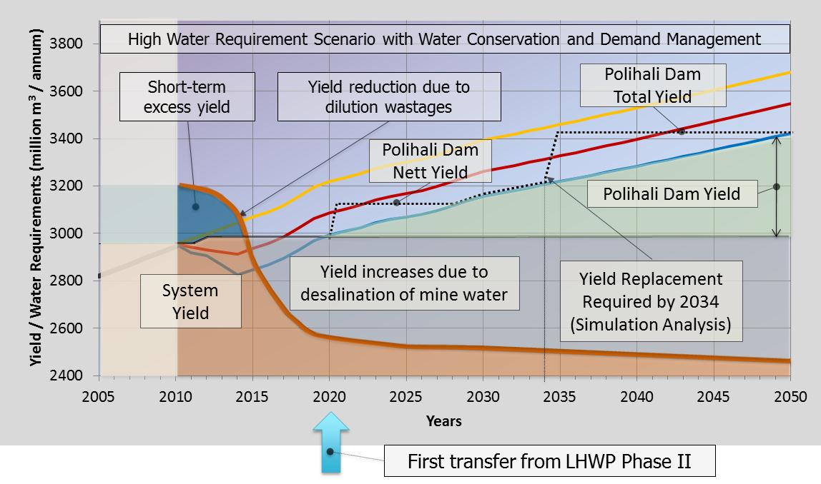**Figure 2: System water balance and target reconciliation scenario**

**Notes on Figure 2**

* Due to the high levels of the dams (May 2011) the system balance shows a short term excess for the first few years.
* The discharge of high salinity mine water will increase once the underground compartments filled and this will require large volumes of releases from Vaal Dam for dilution, which reduces the system yield due to excessive spills and wastage from Bloemhof Dam.
* Desalination and use of the mine effluent prevent these wastages and the system yield increases to about 3 000 million m3/annum by the year 2014.
* The eradication of unlawful irrigation water use by 2013 and the savings through WC/WDM will maintain a positive water balance until the year 2020.
* The implementation of Phase II of the LHWP (Polihali Dam and conveyance infrastructure) by 2020 will ensure sufficient water is available until the year 2049.
* The full yield of LHWP Phase 2 can only be transferred to the VRS if a yield replacement scheme is developed in the Orange River catchment and commissioned by the year 2034.

**Reconciliation Perspectives:**

* Sufficient water can be made available to all users in the Vaal River System only if all the interventions reflected in **Figure 2** are successful implemented.
* Although there are currently sufficient water for supply in the short term (due to full dams), extended delays in achieving the target water saving will increase the risk of water restrictions over the long term and jeopardise sustainable supply until Phase II of the LHWP can deliver water.
* At the recently held SSC for the Crocodile West River System it was indicated that there are several bulk water supply project proposals from local authorities and water service providers to utilise the surplus water in that catchment. In addition augmentation to the Lephalale area is needed from the Crocodile West River System and the water balances indicated there is insufficient surplus water to supply all the proposed bulk abstraction projects. It was therefore recommended to prioritise the bulk abstraction projects before further water use licenses are approved.

The outcomes of this prioritisation exercise will most likely influence the water balance of the Vaal River System and continuous coordination of both SSCs are essential.

1. **General information**

Detailed progress reports on the water resource management strategies can be found at the following link: www.dwa.gov.za/Projects/VaalWRMS/documents.aspx

The Study Manager for this project is Mr Seef Rademeyer, Chief Engineer at the Directorate: National Water Resource Planning (Central).

The next meeting of the Strategy Steering Committee is on 18 April 2012.

__________________________________